1. Pick any one app you use daily (like Zomato, Instagram, or Flipkart) and write a short problem definition for a data science project that could improve the app's user experience. Clearly state the business goal and what data you would need.
2. Use the requests library in Python to fetch the latest 5 posts from the JSONPlaceholder API (https://jsonplaceholder.typicode.com/posts) and print the title of each post. Use requests.get() and response.json().
3. Given a CSV file with columns: song_name, artist, streams, and genre (simulate a mini Spotify dataset with at least 10 rows), write Python code to load the data using pandas and display the number of songs in each genre.
4. Create a simple bar chart using matplotlib to visualize the number of movies per genre from a dataset (you can make up a small dataset with at least 3 genres and 10 movies, like BookMyShow's movie listings).
5. Use ChatGPT to suggest 3 new features that could be engineered from a dataset of online food orders (like Zomato orders: order time, restaurant, cuisine, delivery time, rating). List the features and explain how each could help a data science model.Paste the column names into ChatGPT and ask for feature engineering ideas.

1. App Problem Definition (Zomato)
- App: Zomato
- Problem Definition: Users frequently experience anxiety when delivery times fluctuate or exceed estimates during peak hours or bad weather. Building a machine learning model to accurately predict precise delivery delays right at the checkout screen can significantly set correct expectations.
- Business Goal: Improve user trust and satisfaction, decrease customer support tickets related to late orders, and reduce cart abandonment caused by uncertainty over delivery windows.
- Data Needed:
  - Historical order details (order timestamp, restaurant ID, delivery location coordinates).
  - Real-time operational data (current kitchen prep time, active delivery partner availability, live traffic and weather conditions).
  - Target variable: Actual delivery time vs. initially estimated delivery time.

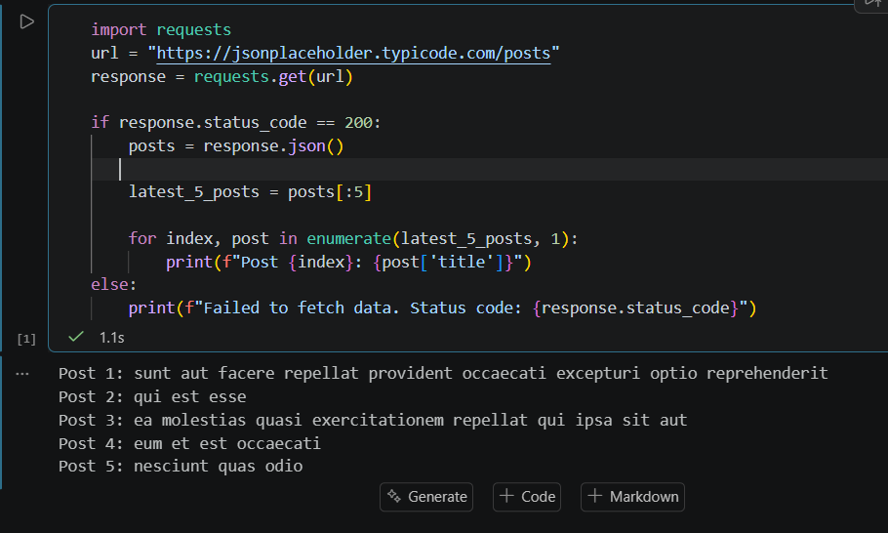

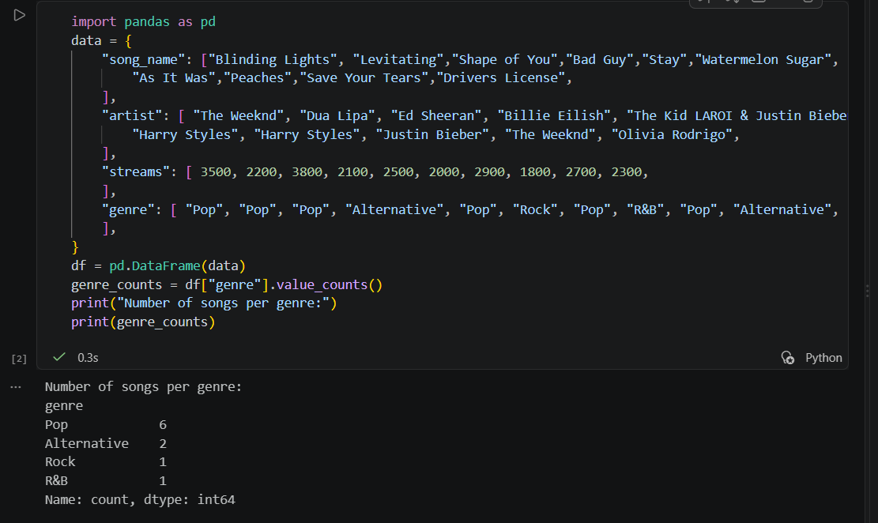

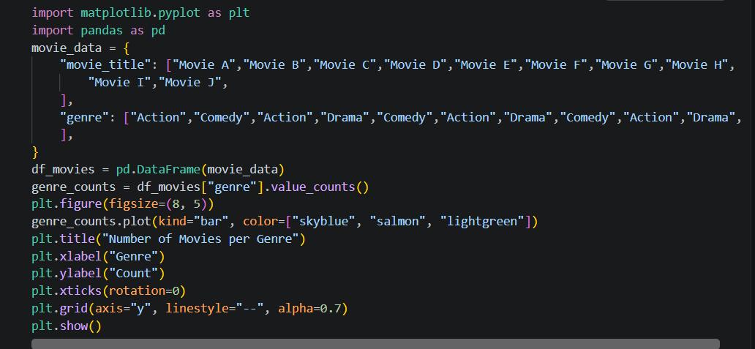

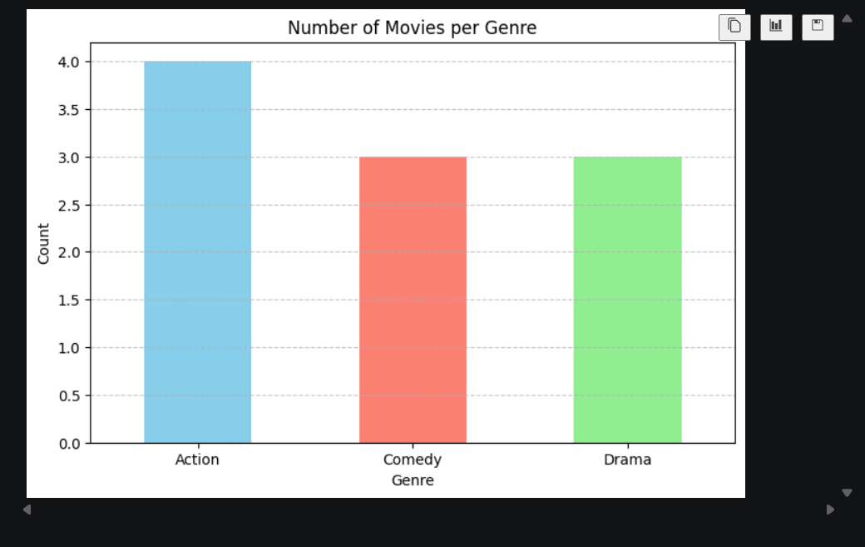

5. Feature Engineering Ideas for Online Food Orders
- is_peak_hour (Extracted from order_time)
  - Explanation: By extracting the hour from order_time and flagging whether an order happens during lunch or dinner rush hours, the model captures kitchen congestion and traffic delays. This helps models predict delivery_time much more accurately.
- restaurant_avg_rating (Aggregated from rating and restaurant)
  - Explanation: Computing the historical average rating for each unique restaurant gives the model a baseline measure of vendor quality and operational efficiency. This helps predict customer satisfaction or identify problematic restaurants.
- cuisine_popularity_score (Aggregated from cuisine)
  - Explanation: Counting how frequently a particular cuisine is ordered overall or by a specific user segment creates a demand density feature. This helps recommendation systems rank restaurants based on trending food preferences.

